### **COVID 19 BULLETIN**

We are pleased to announce that Camp Suwannee will be open for summer camp.

We will have standard sanitizing practices in place as well as other safety measures in order to promote good hygiene and safety for all campers and staff.

Masks will be required in closed settings but also must be available at all times.

On the first day of camp, we will do the following:

* Direct you to a Pre-Screening area to wait to be screened!
* Everyone will be screened and have their temperature taken before entering the building!
* Each parent/Guardian will fill out a screening questionnaire for each camper!
  + Senior Camp - **Only campers will be allowed in to registration and beyond.**
  + Junior Camp – **Only one adult per camper will be allowed in for registration and beyond**
* If each person passes the screening process, they may proceed to Registration area. Please have some form of payment ready in case your account is not settled.

We strongly suggest that if you have any doubts or fears or your child in any way feels less than 100% healthy, keep your child home!

Applications need to be in by June 15th. **Maximum 80 campers**!!

**Walk-ins will not be allowed. If you do not notify us by June 15th, that you will be coming, you will not be allowed to stay.**

**Your Camper’s safety and the safety of all staff and person’s involved in this critical ministry, is our #1 concern.**

Dear Camper Families,

In an effort to minimize illness at camp, we ask that you check on the health of your camper daily beginning 14 days prior to camp. Below is an example of the Pre-screening Health Form that will be filled out upon arrival to Camp Suwannee this summer for every camper and accompanying adult prior to being admitted to the registration/check-in area. Please review this form so that you may check on the health status of your camper prior to arrival.

**SAMPLE**

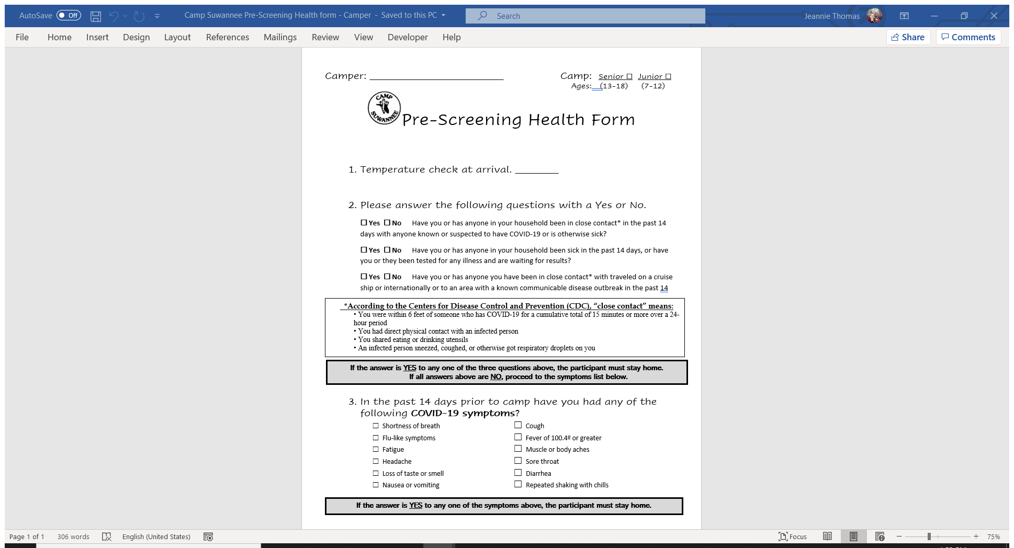

### **Camp Suwannee Logo - FinalCAMP SUWANNEE’S**

### **2021 Summer Camp** REGISTRATION FORM

Send your **$25.00 non-refundable deposit** made payable to: **Fla. Conf. of AC Churches (FLCACC)**

**Note: The deposit is subtracted from the total due.**

Mail to: **Camp Suwannee**

**P.O. Box 4313 Please write the name of the Camper(s) in the Note**

**Dowling Park, Fl. 32064 section of the check.**

|  |  |  |  |  |  |  |  |  |  |  |  |
| --- | --- | --- | --- | --- | --- | --- | --- | --- | --- | --- | --- |
| **Camper’s Information:**  Camper Name\_\_\_\_\_\_\_\_\_\_\_\_\_\_\_\_\_\_\_\_\_\_\_\_\_\_\_\_\_\_\_\_\_\_\_\_\_\_\_\_  M/F \_\_\_\_\_ Age \_\_\_\_\_\_ Grade going into next Fall\_\_\_\_\_\_\_  Date of Birth \_\_\_\_ / \_\_\_\_ / \_\_\_\_\_ MM/DD/YYYY  Mailing Address\_\_\_\_\_\_\_\_\_\_\_\_\_\_\_\_\_\_\_\_\_\_\_\_\_\_\_\_\_\_\_\_\_\_\_\_\_\_ City \_\_\_\_\_\_\_\_\_\_\_\_\_\_\_\_\_\_\_\_\_\_\_\_ State \_\_\_\_\_ Zip \_\_\_\_\_\_\_\_\_  Home Phone ( \_\_\_\_ ) \_\_\_\_ - \_\_\_\_\_\_\_\_  Parent/Guardian’s Name(s): \_\_\_\_\_\_\_\_\_\_\_\_\_\_\_\_\_\_\_\_\_\_\_\_\_\_\_\_\_  Female Guardian Cell Phone ( \_\_\_\_ ) \_\_\_\_ - \_\_\_\_\_\_\_  Relationship\_\_\_\_\_\_\_\_\_\_\_\_\_\_\_\_\_\_\_\_\_\_\_\_\_\_\_\_\_\_\_\_\_\_\_\_\_\_\_\_\_\_  Male Guardian Cell Phone ( \_\_\_\_ ) \_\_\_\_ - \_\_\_\_\_\_\_  Relationship\_\_\_\_\_\_\_\_\_\_\_\_\_\_\_\_\_\_\_\_\_\_\_\_\_\_\_\_\_\_\_\_\_\_\_\_\_\_\_\_\_\_  Main E-Mail\_\_\_\_\_\_\_\_\_\_\_\_\_\_\_\_\_\_\_\_\_\_\_\_\_\_\_\_\_\_\_\_\_\_\_\_\_\_\_\_\_\_\_ | | |  |  | | --- | --- | | Select a Camp **(check one)** | | | \_\_\_\_\_\_ | \_\_\_\_\_\_ | | Sr. Camp | Jr. Camp | | **Ages 13-18**  ***July 11-17*** | **Ages 7-12**  ***July 18-24*** |   **Check here if first time to camp: \_\_\_**  **Costs:**  **Early Registration**  **(if Post marked by 6/1): $285**  **Late Registration: $310**  **Walk-ins: NOT ALLOWED**  **Capacity will be 80 campers** | |
| **Church Information:** If you are a not a member of a church, leave this section blank.  Home Church: \_\_\_\_\_\_\_\_\_\_\_\_\_\_\_\_\_\_\_\_\_\_\_\_\_Church Address:\_\_\_\_\_\_\_\_\_\_\_\_\_\_\_\_\_\_\_\_\_\_\_\_\_\_\_\_\_\_\_\_\_\_\_\_  Name of Pastor or Youth Pastor:\_\_\_\_\_\_\_\_\_\_\_\_\_\_\_\_\_\_\_\_\_\_\_\_\_\_\_\_\_\_\_\_\_\_\_\_\_\_\_\_\_\_\_\_\_\_\_\_\_\_\_\_\_\_\_\_\_\_\_\_ | | | |
|  | **DIET/NUTRITION (Check one):** \_\_\_\_ This camper eats a regular diet.\_\_\_\_This camper eats a regular vegetarian diet. \_\_\_\_This camper has special food needs. (Please describe)\_\_\_\_\_\_\_\_\_\_\_\_\_\_\_\_\_\_\_\_\_\_\_\_\_\_\_\_\_\_\_\_\_\_  \_\_\_\_\_\_\_\_\_\_\_\_\_\_\_\_\_\_\_\_\_\_\_\_\_\_\_\_\_\_\_\_\_\_\_\_\_\_\_\_\_\_\_\_\_\_\_\_\_\_\_\_\_\_\_\_\_\_\_\_\_\_\_\_\_\_\_\_\_\_\_\_\_\_\_\_\_\_\_\_\_  If your child has a food allergy or special diet, please indicate that also and list it here: \_\_\_\_\_\_\_\_\_\_\_\_\_\_\_\_\_\_\_\_\_\_\_\_\_\_\_\_\_\_\_\_\_\_\_\_\_\_\_\_\_\_\_\_\_\_\_\_\_\_\_\_\_\_\_\_\_\_\_\_\_\_\_\_\_\_\_\_\_\_\_\_\_\_\_\_\_\_\_\_\_  **RESTRICTIONS:**  \_\_\_\_I feel the camper can participate in any and all camp activities without restrictions.  \_\_\_\_I feel the camper can participate with the following restrictions or adaptations. (Please describe on a separate sheet) **You will be asked at Registration to fill out a COVID 19 screening questionnaire and will have your temperature taken before being allowed to proceed to registration****2021 CAMP SUWANNEE** **Summer Camp***Where* **Christ** *is exalted through camping* | |

**CAMPER RELEASE**

Your child’s safe return from camp is of great concern to us. Only the person(s) you name on this form will be allowed to pick up your child. Please fill out the form below with the information requested, and be sure that it is signed by a parent or legal guardian. A separate form is needed for each child. **The individual picking up your child(ren) may be asked to produce a photo ID in order to leave with them.**

Child’s name \_\_\_\_\_\_\_\_\_\_\_\_\_\_\_\_\_\_\_\_\_\_\_\_\_\_\_\_\_\_\_\_\_\_\_\_\_\_\_\_\_\_\_\_\_\_\_\_\_\_\_\_\_\_\_\_\_\_\_\_\_\_\_\_

Date your child will be picked up \_\_\_\_\_\_\_\_\_\_\_\_\_\_\_\_\_\_\_\_\_\_\_\_\_\_\_\_\_\_\_\_\_\_\_\_\_\_\_\_\_\_\_\_\_\_\_\_

My child may be picked up at camp by:

\_\_\_\_ a parent or legal guardian \_\_\_\_\_\_\_\_\_\_\_\_\_\_\_\_\_\_\_\_\_\_\_\_\_\_\_\_\_\_\_\_\_\_\_\_\_\_\_\_\_\_\_\_\_\_

name

\_\_\_\_\_\_\_\_\_\_\_\_\_\_\_\_\_\_\_\_\_\_\_\_\_\_\_\_\_\_\_\_\_\_\_\_\_\_\_\_\_\_\_\_\_\_

name

\_\_\_\_ church vehicle driver

\_\_\_\_ camp bus driver

\_\_\_\_ other individual(s) \_\_\_\_\_\_\_\_\_\_\_\_\_\_\_\_\_\_\_\_\_\_\_\_\_\_\_\_\_\_\_\_\_\_\_\_\_\_\_\_\_\_\_\_\_\_\_\_\_\_\_\_\_\_

name

\_\_\_\_\_\_\_\_\_\_\_\_\_\_\_\_\_\_\_\_\_\_\_\_\_\_\_\_\_\_\_\_\_\_\_\_\_\_\_\_\_\_\_\_\_\_\_\_\_\_\_\_\_\_

name

Parent name \_\_\_\_\_\_\_\_\_\_\_\_\_\_\_\_\_\_\_\_\_\_\_\_\_\_\_\_\_\_\_\_\_\_\_ Phone ( ) \_\_\_\_\_\_\_\_\_\_\_\_\_\_\_\_

please print

Parent signature \_\_\_\_\_\_\_\_\_\_\_\_\_\_\_\_\_\_\_\_\_\_\_\_\_\_\_\_\_\_\_\_\_\_\_\_\_\_\_\_\_\_\_\_\_\_\_\_\_\_\_\_\_\_\_\_\_\_\_\_\_

please sign

**NOTE: If the person(s) whom you list become(s) unable to pick up your child, you must call the Facility Director @ 386-647-6624 before the end of the week. We will not release your child to any person not listed on this form.**

**. . . . . . . . . . . . . . . . . . . . . . . . . . . . . . . . . . . . . . . . . . . . . . . . . . . . . . . . . . . . . . . . . . . . . . . . . . .**

*Office use only*

Change of instructions:

Caller \_\_\_\_\_\_\_\_\_\_\_\_\_\_\_\_\_\_\_\_\_\_\_ Date \_\_\_\_\_\_\_\_\_\_\_\_\_ Received by \_\_\_\_\_\_\_\_\_\_\_\_\_\_\_\_\_\_

**. . . . . . . . . . . . . . . . . . . . . . . . . . . . . . . . . . . . . . . . . . . . . . . . . . . . . . . . . . . . . . . . . . . . . . . . . . .**

Camper released to:

\_\_\_\_\_\_\_\_\_\_\_\_\_\_\_\_\_\_\_\_\_\_\_\_\_\_\_\_\_\_\_\_\_\_\_\_\_\_\_\_\_\_\_\_\_\_\_\_\_\_\_\_\_\_\_\_\_\_\_\_\_\_\_\_\_\_\_\_\_\_\_\_\_\_\_ Printed Name date

\_\_\_\_\_\_\_\_\_\_\_\_\_\_\_\_\_\_\_\_\_\_\_\_\_\_\_\_\_\_\_\_\_\_\_\_\_\_\_\_\_\_\_\_\_\_\_\_\_\_\_\_\_\_\_\_\_\_\_\_\_\_\_\_\_\_\_\_\_\_\_\_\_\_\_

Signature date

|  |  |  |  |
| --- | --- | --- | --- |
| **Last Name:\_\_\_\_\_\_\_\_\_\_\_\_\_\_\_\_\_\_\_, First Name:\_\_\_\_\_\_\_\_\_\_\_\_\_\_\_\_\_\_\_\_\_\_\_\_\_\_\_** Health Information | | | |
| In case of emergency notify | \_\_\_\_\_\_\_\_\_\_\_\_\_\_\_\_\_\_\_ | Home Phone | ( \_\_\_\_ ) \_\_\_\_ - \_\_\_\_\_\_\_\_ |
| Relationship to camper | \_\_\_\_\_\_\_\_\_\_\_\_\_\_\_\_\_\_\_ | Work Phone | ( \_\_\_\_ ) \_\_\_\_ - \_\_\_\_\_\_\_\_ |
| Personal Physician | \_\_\_\_\_\_\_\_\_\_\_\_\_\_\_\_\_\_\_ | Phone | ( \_\_\_\_ ) \_\_\_\_ - \_\_\_\_\_\_\_\_ |
| Insurance Company | \_\_\_\_\_\_\_\_\_\_\_\_\_\_\_\_\_\_\_ | Policy # | \_\_\_\_\_\_\_\_\_\_\_\_\_\_\_\_\_ |
| Insurance Company Address | \_\_\_\_\_\_\_\_\_\_\_\_\_\_\_\_\_\_\_\_\_\_\_\_\_\_\_\_\_\_\_\_\_\_\_\_\_\_\_\_\_\_\_\_\_\_\_\_ | | |
| List all medications required on a regular basis \_\_\_\_\_\_\_\_\_\_\_\_\_\_\_\_\_\_\_\_\_\_\_\_\_\_\_\_\_\_\_\_\_\_\_\_\_\_ | | | |
| Allergies/Physical Restrictions \_\_\_\_\_\_\_\_\_\_\_\_\_\_\_\_\_\_\_\_\_\_\_\_\_\_\_\_\_\_\_\_\_\_\_\_\_\_\_\_\_\_\_\_\_\_\_\_\_ | | | |

If this camper has any medical or physical limitations that could restrict them from participating in any camp activities, an affidavit, signed by the camper’s physician, must accompany this application in order for the camper to participate in any camp activities that could affect the campers physical condition.

**For Medical Treatment:** I understand that the Camp Director for the week is serving as the guardian of my child while attending camp and has my permission and support to act on my behalf. By signing below, I agree to hold the Florida Conference of Advent Christian Churches (FLCACC) or any employee or volunteers of said organization, harmless for any accidental injury to my child while participating in any and all camp programs. I also agree to hold them harmless if my child tests positive for COVID 19 after attending camp. I authorize the Camp Director for the week and/or weekly staff to consent to any and all x-rays, examinations, anesthetic, medical or surgical treatment and hospital care (including, but not limited to, intravenous solutions and/or blood transfusions), to be rendered to my child under general and specific supervision and of the advice of any physician or surgeon licensed to practice in the United States of America. I also agree to be financially responsible for any and all medical and/or surgical procedures rendered to my child. **I understand that my child must undergo a health check by the Camp Nurse before registration, and if anything of concern is found, options will be discussed before being allowed to proceed to registration.** I also understand that photographs of my child may be taken during camp and I give my permission for my child’s photograph to be used in Camp Suwannee promotional material.

**ALL APPLICATIONS MUST BE SIGNED BY THE**

Parent/Guardian

Print Name: \_\_\_\_\_\_\_\_\_\_\_\_\_\_\_\_\_\_\_\_\_\_\_\_\_\_\_\_\_\_\_\_\_\_\_\_\_

Signature: \_\_\_\_\_\_\_\_\_\_\_\_\_\_\_\_\_\_\_\_\_\_\_\_\_\_\_\_\_\_\_\_\_\_\_\_\_\_\_ Date \_\_\_\_\_\_\_\_\_\_\_\_\_

**MEDICIAL INSURANCE INFORMATION: *Please attach a copy of your insurance card to the back of this form. Copy both sides of the card so information is readable.***

Is this camper covered by family medical/hospital insurance? \_\_\_\_Yes \_\_\_\_No

Insurance Company Phone Number (\_\_\_)\_\_\_\_\_\_\_\_\_\_\_\_\_\_\_\_\_\_\_\_\_\_\_\_\_\_\_\_\_\_\_\_\_

Some non-prescription medications may be stocked in the camp's Nurses Station and may be given to campers on as needed basis to manage illness and injury. *List any medications the camper should not be given (ie. Tylenol, Advil, Motrin, Sudafed, Robitussin, cough drops, Aloe Antibiotic cream, Kaopectate, Pepto-Bismol, Calamine lotion, etc.)\_\_\_\_\_\_\_\_\_\_\_\_\_\_\_\_\_\_\_\_\_\_\_\_\_\_\_\_\_\_\_\_\_\_\_\_\_\_\_\_*\_\_\_\_\_\_\_\_\_\_\_\_\_\_\_\_

**MEDICATION**

**\_\_\_\_\_** This camper will **NOT** take any daily medications while attending camp.

\_\_\_\_\_\_This camper will take the following daily medication(s) while at camp:

"Medication" is any substance a person takes to maintain and/or improve their health. This includes vitamins & natural remedies.

***\*\*\*Florida law requires original pharmacy containers with labels which show the camper’s name and how the medication should be given. Provide enough of each medication to last the entire time the camper will be at camp. \*\*\****



**General Health Information: *Please fill out to the best of your ability***

(Please circle all items that apply, past or present, to your health history. Explain all “Yes” answers.)

1. Back Problems YES NO 15. High Blood Pressure YES NO

2. Heart Disease YES NO 16. History of Asthma? YES NO

3. Contacts/glasses YES NO 17. History of ADD or ADHD YES NO

4. Convulsions/Seizures YES NO 18. History of bed-wetting? YES NO

5. Diabetes YES NO 19. History of Cancer/Leukemia? YES NO

6. Diagnosed with a heart murmur? YES NO 20. History of Sleepwalking? YES NO

7. Ear infections YES NO 21. Kidney Disease YES NO

8. Joint Problems (knees, ankles etc.) YES NO 22. Menstrual Cramps YES NO

9. Emotional disturbances YES NO 23. Migraine Headaches YES NO

10. Ever had a head injury YES NO 24. Motion sickness YES NO

11. Ever been hospitalized? YES NO 25. Fainting or Dizziness? YES NO

12. Ever had surgery YES NO 26. Nose bleeding YES NO

13. Hearing impairment YES NO 27. Tested positive for COVID 19 YES NO

14. Problems with diarrhea/constipation YES NO 28. Had symptoms for COVID 19 YES NO

29. Skin problems (rash, itching etc.) ………………………………………………………………………………………. YES NO

30. Chronic or recurring illness/condition? ………………………………………………………………………………. YES NO

31. Recent injury, illness or infectious disease? (within last 6 months)…………………………………… YES NO

32. Had mononucleosis in the past 12 months? ………………………………………………………………………. YES NO

33. Hemophilia or other Bleeding Disorder? ……………………………………………………………………………… YES NO

34. Other medical history not specified? …………………………………………………………………………………… YES NO

35. Traveled outside of the United States in the past 9 months? ……………………………………………. YES NO

***Please explain “Yes” answers in the space below*,** noting the number of the questions:

\_\_\_\_\_\_\_\_\_\_\_\_\_\_\_\_\_\_\_\_\_\_\_\_\_\_\_\_\_\_\_\_\_\_\_\_\_\_\_\_\_\_\_\_\_\_\_\_\_\_\_\_\_\_\_\_\_\_\_\_\_\_\_\_\_\_\_\_\_\_\_\_\_\_\_\_\_\_\_\_\_\_\_\_\_\_\_\_\_\_\_\_

\_\_\_\_\_\_\_\_\_\_\_\_\_\_\_\_\_\_\_\_\_\_\_\_\_\_\_\_\_\_\_\_\_\_\_\_\_\_\_\_\_\_\_\_\_\_\_\_\_\_\_\_\_\_\_\_\_\_\_\_\_\_\_\_\_\_\_\_\_\_\_\_\_\_\_\_\_\_\_\_\_\_\_\_\_\_\_\_\_\_\_\_\_

For travel outside the country, please name country(s) visited and dates of travel:

\_\_\_\_\_\_\_\_\_\_\_\_\_\_\_\_\_\_\_\_\_\_\_\_\_\_\_\_\_\_\_\_\_\_\_\_\_\_\_\_\_\_\_\_\_\_\_\_\_\_\_\_\_\_\_\_\_\_\_\_\_\_\_\_\_\_\_\_\_\_\_\_\_\_\_\_\_\_\_\_\_\_\_\_

Immunizations: (Fill out the following portion of this form or attach a copy of the camper's immunizations record.)

|  |  |  |
| --- | --- | --- |
|  | Year primary series completed | Year of last booster |
| Tetanus (DT, DTaP, Td or Tdap) |  |  |

Tuberculin Test Type: \_\_\_\_\_\_\_\_\_\_\_\_\_ Year Last Given: \_\_\_\_\_\_\_\_\_ Result: \_\_\_\_\_\_\_

Date of Last Physical: ­­­­­­­­­­­­­­­­­\_\_\_\_\_\_\_\_\_\_\_\_\_\_\_\_ (MM/DD/YYYY)

**MENTAL, SOCIAL, EMOTIONAL HEALTH: Circle or *Check "Yes" or "No" for each statement.***

Has/Does the camper:

1. Ever been treated for attention deficit disorder (ADD) or attention deficit/hyperactivity disorder (AD/HD)? \_\_\_\_\_\_\_\_\_\_\_\_\_\_\_\_\_\_\_\_\_\_\_\_\_\_\_\_\_\_\_\_\_\_\_\_\_\_\_\_\_\_\_\_\_\_\_\_\_\_\_\_\_\_\_\_\_\_\_\_\_\_\_\_\_\_\_\_\_\_\_\_\_\_\_\_\_\_\_\_\_Yes/No

2. Take medication for ADD or AD/HD during the school year that the camper does not/may not take during the summer?\_\_\_\_\_\_\_\_\_\_\_\_\_\_\_\_\_\_\_\_\_\_\_\_\_\_\_\_\_\_\_\_\_\_\_\_\_\_\_\_\_\_\_\_\_\_\_\_\_\_\_\_\_\_\_\_\_\_\_\_\_\_\_\_\_\_\_\_\_\_ Yes/No

3. Take medication for ADD or AD/HD during the summer? \_\_\_\_\_\_\_\_\_\_\_\_\_\_\_\_\_\_\_\_\_\_\_\_\_\_\_\_\_\_\_\_\_\_Yes/No

3. Ever been treated for emotional or behavioral difficulties or an eating disorder?\_\_\_\_\_\_\_\_\_\_\_\_\_\_\_\_ Yes/No

4. During the past 12 months, seen a professional to address mental/emotional health concerns?\_\_\_\_Yes/No

5. Had a significant life event that continues to affect the camper’s life? \_\_\_\_\_\_\_\_\_\_\_\_\_\_\_\_\_\_\_\_\_\_\_\_ Yes/No

(History of abuse, death of a loved one, family change, adoption, foster care, new sibling, survived a disaster, etc.)

***Please explain “Yes” answers on the lines below,*** noting the number of the questions. The camp may contact you for additional information.\_\_\_\_\_\_\_\_\_\_\_\_\_\_\_\_\_\_\_\_\_\_\_\_\_\_\_\_\_\_\_\_\_\_\_\_\_\_\_\_\_\_\_\_\_\_\_\_\_\_\_\_\_\_\_\_\_\_

**Keep this page at home for reference before camp**

**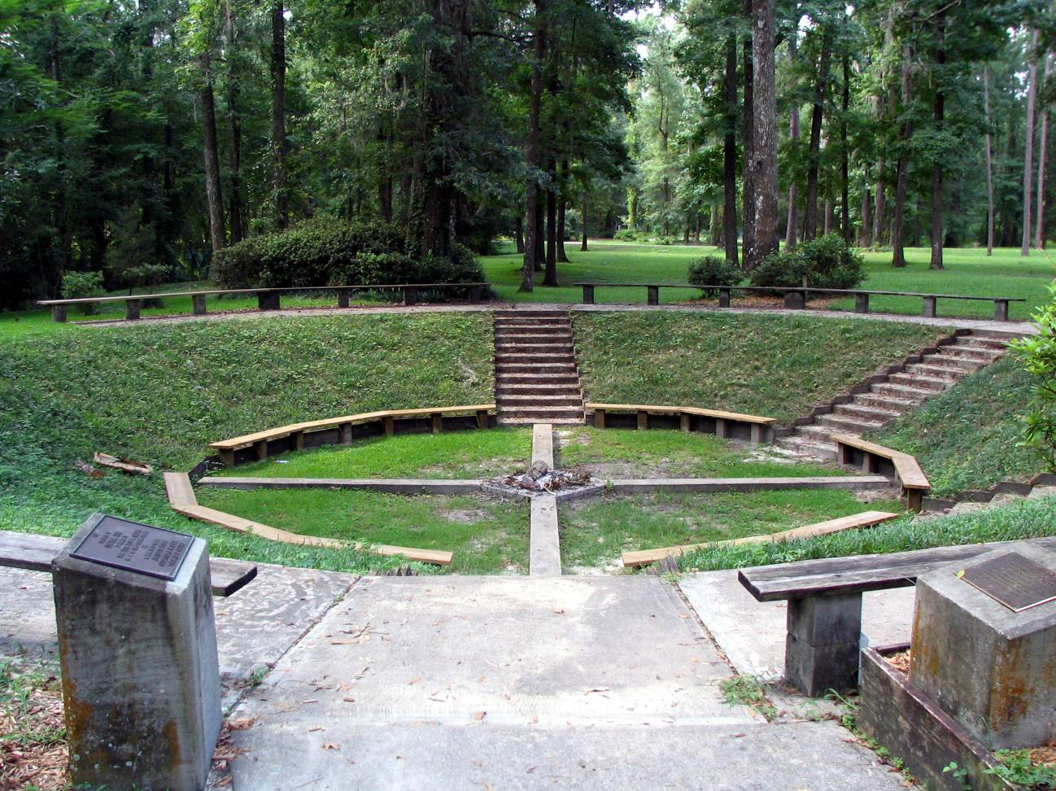**

#### Camp Suwannee 2021

|  |  |  |  |  |  |  |  |  |  |  |  |  |  |  |
| --- | --- | --- | --- | --- | --- | --- | --- | --- | --- | --- | --- | --- | --- | --- |
| **Sr. Camp** *(Ages 13-18) July 11-17* |  | |  |  | | --- | --- | | Cost | | |  | Applications postmarked: | | **$285.00** *per camper* | **by June 15th** | | **$310.00** *per camper* | **after June 15th** | | |  |  | | --- | --- | |  |  |   *See below for family discounts* | | |
| **Jr. Camp** *(Ages 7-12) July 18-24* |  |
| **You will be asked at Registration to fill out a COVID 19 screening questionnaire and will have your temperature taken before being allowed to proceed to registration** |  |
| *This is an overnight camp.*  *Call 386-647-6624* with any questions | | ***We cannot guarantee a spot if you do not pre-register!!!!***  ***Walk-ins will pay $25 extra!!*** |

**Registration** begins at 2:00 p.m. on the Sunday camp begins and **Pickup** is at 10 a.m. on the following Saturday. *The camp facilities, lodging and food service will not be available prior to or after those times.* **Campers will only be placed in cabins with other campers and staff of the same gender!**

Family Discounts:

Families sending **2** campers**... discount of $15 per camper**

Families sending **3** campers**... discount of $20 per camper**

Families sending **more than 3** campers...cost for **fourth child on** is **$220 per camper**

**Note: *Family discounts are available up until Registration.***

**Snack Shack:** Snacks and drinks are for sale twice a day, $25 should be enough for the week. If making out a check, please make it out to **Camp Suwannee**, **not FLCACC**. Camp T-shirts will also be available.

***Lice Policy: As you prepare your child for summer camp, please take a few minutes to check your child for head lice. This is easily accomplished by lifting up the hair along the temple, behind the ears and along the back of the neck. If you find lice, please treat your child and their belongings with products that are available for this purpose.***

***We will be checking each camper before registration for lice. If evidence of lice is found, the camper will not be allowed to stay for camp. They will need to be treated and may return if successfully treated. If not, your money will be refunded, all but the deposit, and the child will be sent home with you.***

***As with all our medical policies and health procedures, this policy has been put in place to make summer camp a safe and enjoyable experience for all our campers. Thank you in advance for complying with our request. For further information on head lice and proper treatment, go to*** [***www.headlice.org***](http://www.headlice.org)***.***

What Not to Bring

* **NO ELECTRONIC DEVICES**
* Fireworks
* Lighters
* Knives
* Weapons of any kind
* Drugs, Alcohol or Tobacco

**Possession of alcohol or drugs of any kind will result in immediate dismissal and possibly exclusion from future events!!!**

**What to Bring**

* Bible, pencil and paper
* Bedding or sleeping bag & pillow
* Casual clothing and shoes
* Grubby clothes and shoes
* Toiletries and towels
* Swimsuit and towel (conservative, one piece)
* Flip flops/sandals/water shoes
* Dirty clothes bag
* Light jacket or sweatshirt
* Money for snacks and T-shirt, if desired
* Sun block and bug repellant
* Flashlight
* Reusable Water bottle

|  |  |  |
| --- | --- | --- |
| **Camp Suwannee** | Picture 354 | |
| **IMG_0183_edited** | | **2021** |
| We hope and pray we will see you there! | | |

**Camp Suwannee**

**@ Advent Christian Village**

**Physical Address:**

10063 Dowling Park Drive

Live Oak, Fl. 32064

[**http://www.acvconference.net/facilities/camp\_suwannee.aspx**](http://www.acvconference.net/facilities/camp_suwannee.aspx)

**Mailing address:**

PO Box 4313

##### Dowling Park, FL. 32064

386-647-6624

